Astana IT University ==== Web Technologies
Assignment #2 Report: Advanced CSS
Student Name: | Ramazanov Maxsutkhan
Group: | IT-2506
GitHub Repository: | github
Constraints Compliance: | Strict compliance: 0 Bootstrap, 0 JavaScript, 0 Media Queries (@media).

Task 1. Geometric Composition (CSS Grid)
Requirements & Goals: Reproduce the Mondrian geometric artwork using a single CSS Grid container with 6 columns and 6 rows. The composition must remain strictly square, scale dynamically with window dimensions without exceeding viewport height, and form black dividing lines exclusively via grid gap properties without using borders or margins on the blocks.
Implementation Logic: The canvas is mapped to a 6×6 coordinate system (36 cells). The container is styled with 'aspect-ratio: 1 / 1' and fluid dimensions 'width: 78vmin; height: 78vmin; max-height: 80vh; max-width: 90vw'. Viewport minimum units (vmin) guarantee that the container scales fluidly across all screen sizes while never exceeding screen height. Dividing lines are formed by 'background-color: #050507' and 'gap: 1vmin'. The 7 colored blocks are positioned via column and row spans without fixed sizes or floats:
• Blue block: grid-column: 1 / span 2; grid-row: 1 / span 3;
• Top White block: grid-column: 3 / span 4; grid-row: 1 / span 1;
• Yellow block: grid-column: 3 / span 2; grid-row: 2 / span 2;
• Middle-Right White block: grid-column: 5 / span 2; grid-row: 2 / span 3;
• Large Red block: grid-column: 1 / span 3; grid-row: 4 / span 3;
• Black Accent block: grid-column: 4 / span 1; grid-row: 4 / span 3;
• Bottom-Right White block: grid-column: 5 / span 2; grid-row: 5 / span 2.
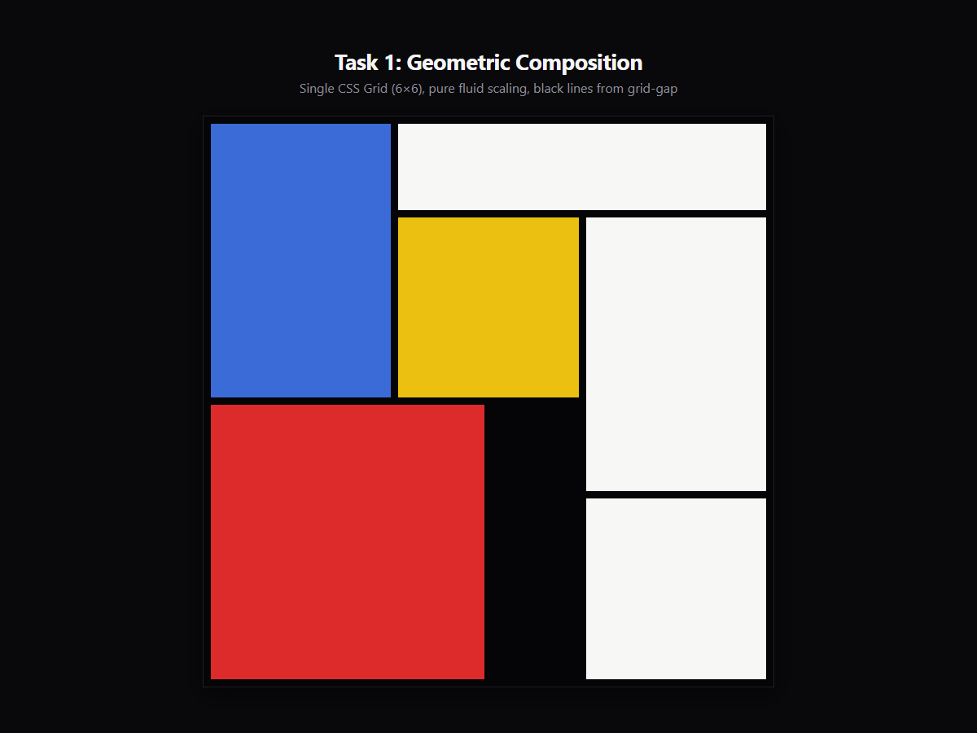
Key CSS Code: Key CSS implementation for Task 1:

.mondrian-grid {
display: grid;
grid-template-columns: repeat(6, 1fr);
grid-template-rows: repeat(6, 1fr);
width: 78vmin;
height: 78vmin;
aspect-ratio: 1 / 1;
max-width: 90vw;
max-height: 80vh;
gap: 1vmin;
background-color: #050507;
padding: 1vmin;
}
.block-blue { grid-column: 1 / span 2; grid-row: 1 / span 3; background-color: #3b6bd6; }
.block-white-top { grid-column: 3 / span 4; grid-row: 1 / span 1; background-color: #f7f7f5; }
.block-yellow { grid-column: 3 / span 2; grid-row: 2 / span 2; background-color: #ecc011; }
.block-white-mid { grid-column: 5 / span 2; grid-row: 2 / span 3; background-color: #f7f7f5; }
.block-red { grid-column: 1 / span 3; grid-row: 4 / span 3; background-color: #dd2a2a; }
.block-black { grid-column: 4 / span 1; grid-row: 4 / span 3; background-color: #050507; }
.block-white-bot { grid-column: 5 / span 2; grid-row: 5 / span 2; background-color: #f7f7f5; }

Task 2. Component Library (Flexbox Only)
Requirements and goals: Create a library of 5 common user interface components assembled on one page. Strict restrictions: Flexbox only (no CSS grid, floating elements, fixed width/height in layout containers, no media queries). All components have a single minimalistic design system in dark colors (black surface with purple inserts).
Component implementation scheme: 1. Navigation Bar: "left margin: automatic" and "compression when bending: 0" the action button group is glued to the right edge regardless of the number of links or their length.
"2" Row of cards of the same height: "align elements: stretch" aligns the height of the cards with different description lengths, while "field on top: automatically" aligns the buttons along the same bottom line without a fixed height.
"3". Pagination panel: Numbered buttons in the center, framed by arrows, with the result pinned to the right edge ("margin-left: auto"), and an elegant transfer using "flex-wrap: transfer".
4. Comment block: Contains a clean gray avatar ("flex-shrink 0") next to the highlighted text column ("flex-grow: 1; minimum width: 0"). The text is carefully transferred and never slips under the avatar.
5. Price table: The recommended layout is higher than the neighbors, without a fixed height, which is achieved through a content-based structure, additional vertical margins, and "center alignment."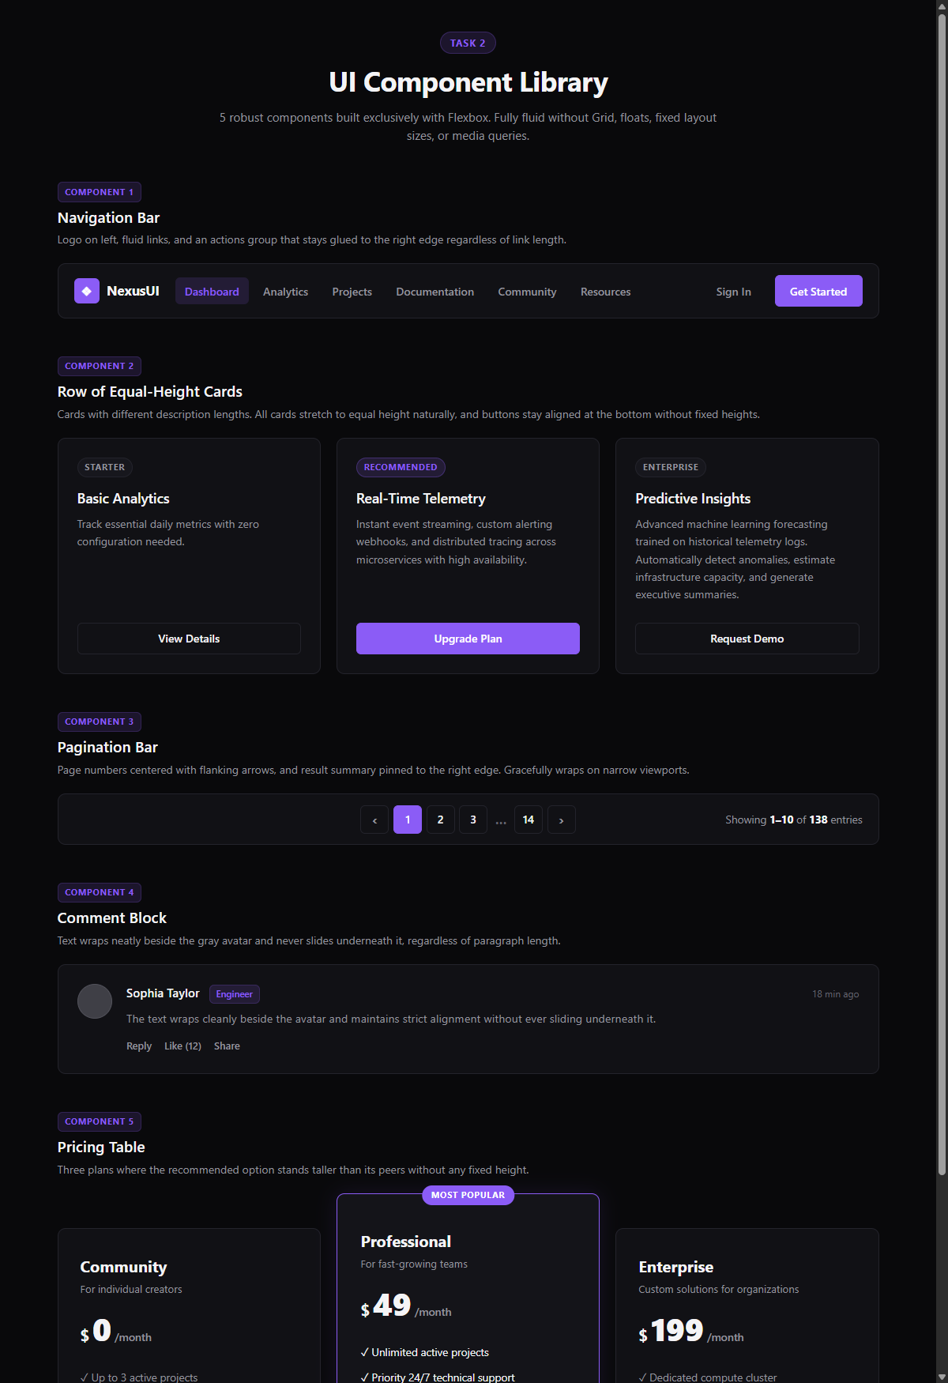
)
Key CSS Code: Key CSS patterns used across the component library:

.navbar-actions { margin-left: auto; flex-shrink: 0; }
.cards-row { display: flex; align-items: stretch; flex-wrap: wrap; }
.card { display: flex; flex-direction: column; flex: 1 1 240px; }
.card-button { margin-top: auto; width: 100%; }
.pagination-bar { display: flex; align-items: center; justify-content: space-between; flex-wrap: wrap; }
.pagination-nav { flex: 2 1 auto; justify-content: center; }
.pagination-info { margin-left: auto; }
.comment-avatar { width: 44px; height: 44px; border-radius: 50%; background-color: #3f3f46; flex-shrink: 0; }
.comment-body { display: flex; flex-direction: column; flex-grow: 1; min-width: 0; }
.pricing-table { display: flex; align-items: center; justify-content: center; flex-wrap: wrap; }
.pricing-card-featured { padding: 2.75rem 1.85rem; border: 1px solid var(--primary); }

Task 3. Three Layouts, One Markup (Grid & Flexbox)
Requirements and objectives: A catalog of 12 articles with different titles and text lengths, presented in 3 different layouts: (1) A grid of cards, (2) A compact list, and (3) The first page of the journal with the main article. Switching between layouts is performed strictly by changing one class in the container (.layout-grid, .layout-list, .layout-magazine), while the HTML markup remains completely unchanged.
Brief description of the purpose of the CSS tool: Description of the CSS tool in one sentence for each mode (mandatory requirement for the purpose).:
• Mode 1 (card grid): CSS grid with "repeat (auto-fit, minmax(...))" function dynamically calculates the number of adaptive columns according to the width of the viewport, while Flexbox inside each card controls the vertical position and alignment of the lower metadata.
• Mode 2 (compact list): The CSS grid creates a vertical stack of one column, while when rows are aligned in Flexbox, the thumbnail is positioned on the left, the copy of the article is in the middle, and the publication date is attached to the right edge.
• Mode 3 (Front page of the magazine): CSS grid with "automatic grid distribution: dense" and multi-track intervals (2 columns × 2 rows) emphasizes the main theme, while surrounding articles are placed in the remaining cells, and Flexbox structures the internal hierarchy.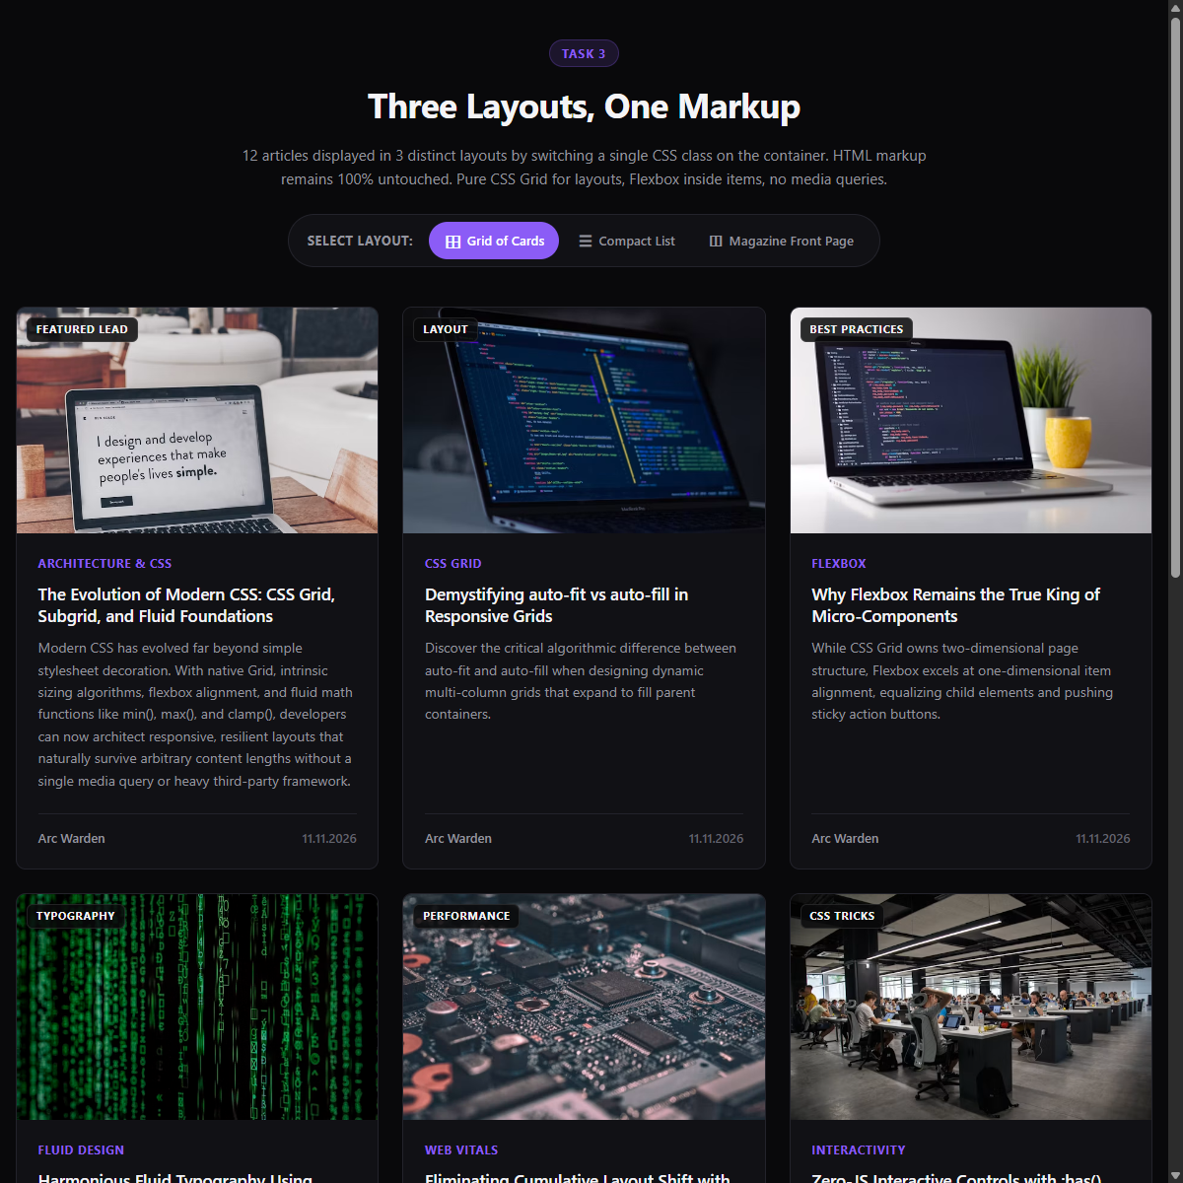
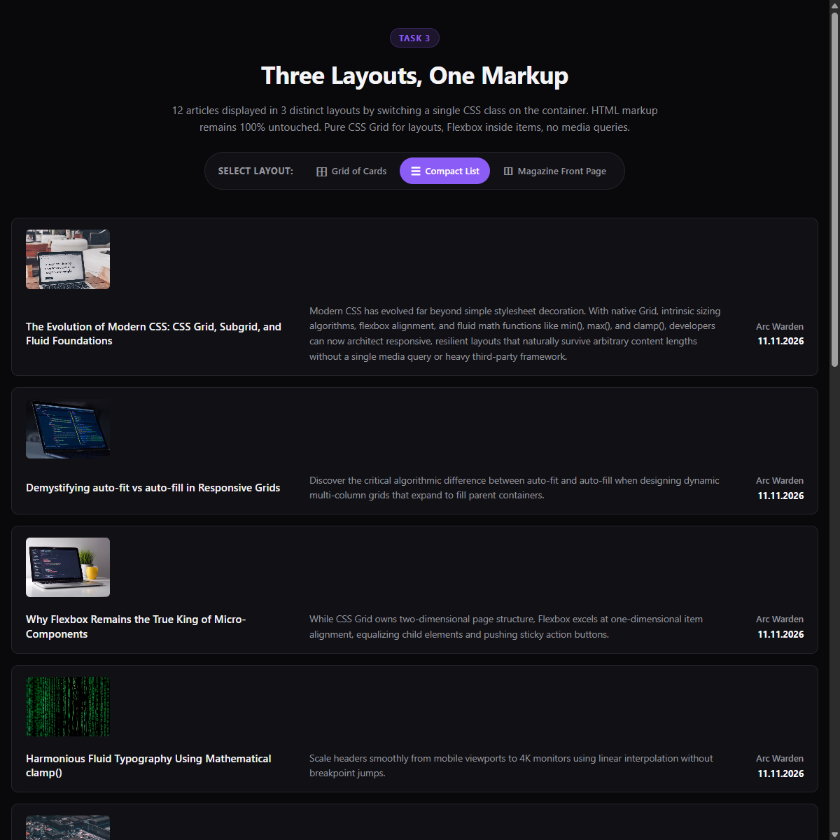
Figure: Task 3 - Mode 2: Compact Row List with Right-Pinned Dates (.layout-list)
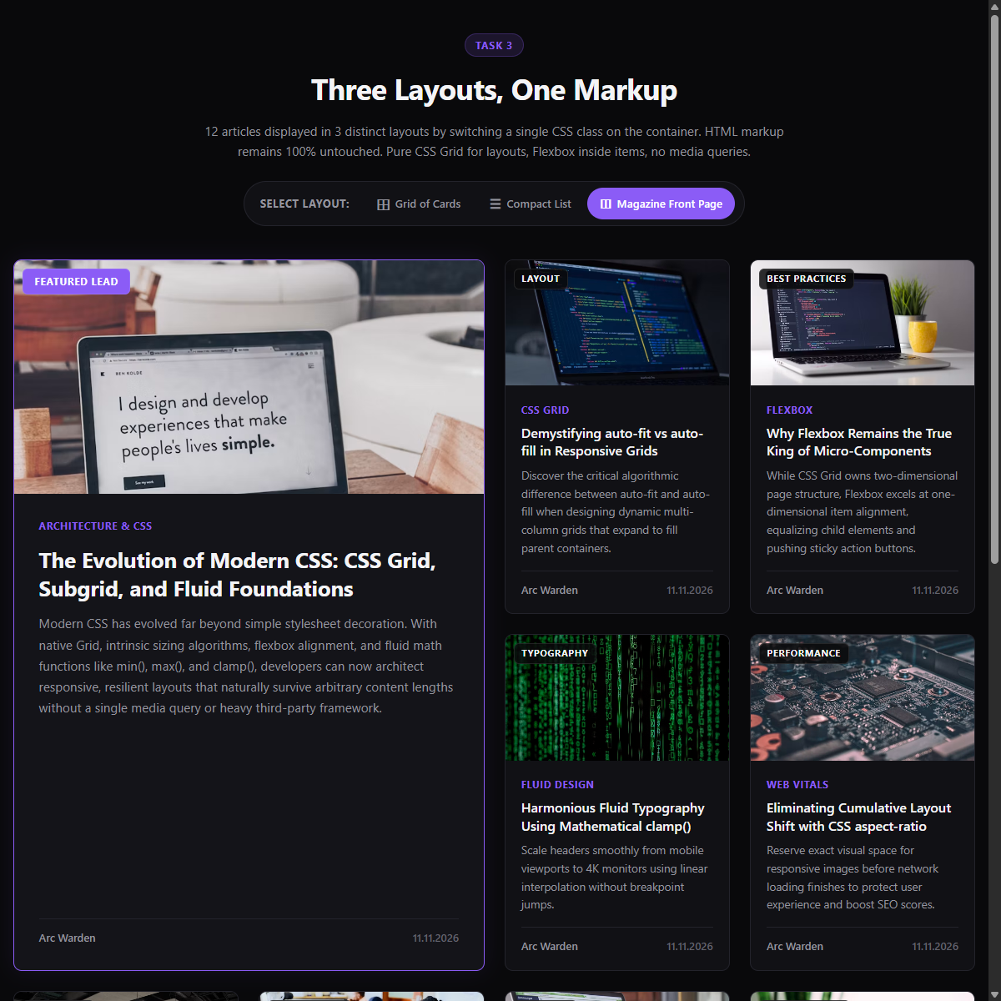
Figure: Task 3 - Mode 3: Magazine Front Page with Asymmetric Lead Article (.layout-magazine)
Key CSS Code: Key CSS implementation demonstrating container class switching and untouched HTML:

.content-container.layout-grid {
display: grid;
grid-template-columns: repeat(auto-fit, minmax(min(100%, 280px), 1fr));
gap: 1.5rem;
}
.content-container.layout-grid .article-card { display: flex; flex-direction: column; }
.content-container.layout-grid .article-meta { margin-top: auto; justify-content: space-between; }
.content-container.layout-list {
display: grid;
grid-template-columns: 1fr;
gap: 1rem;
}
.content-container.layout-list .article-card {
display: flex;
flex-direction: row;
align-items: center;
gap: 1.25rem;
flex-wrap: wrap;
}
.content-container.layout-list .article-thumb { width: 120px; height: 85px; flex-shrink: 0; }
.content-container.layout-list .article-meta { margin-left: auto; text-align: right; }
.content-container.layout-magazine {
display: grid;
grid-template-columns: repeat(auto-fit, minmax(min(100%, 250px), 1fr));
grid-auto-flow: dense;
gap: 1.5rem;
}
.content-container.layout-magazine .item-lead {
grid-column: span 2;
grid-row: span 2;
}

Conclusion & Learning Outcomes
A brief description of the knowledge gained: Thanks to this assignment, several basic concepts of modern interface development were mastered:

1. Clear separation of layout responsibilities: we learned when to use CSS Grid and when to use Flexbox. The CSS grid is optimal for 2-dimensional macroscopic layouts (geometric canvas of task 1 and multi-track container states of task 3), while Flexbox does an excellent job with 1-dimensional content distribution and micro component alignment (task 2 components and internal map elements).

2. Smooth reaction without stopping: I learned how to create truly flexible web interfaces without resorting to media queries (@media) or bloated CSS frameworks. Using automatic fitting using the minmax(), clamp(), vmin, and flex-wrap modules allows you to create layouts that continuously adapt to arbitrary viewing screen sizes and variable content lengths.

3. Zero-level JavaScript State Management: Modern CSS pseudo-classes such as : has() and container classes are used to provide interactive layout switching while keeping HTML markup 100% intact and avoiding JavaScript overhead.

4. CSS Security principles: Implemented strategies such as flex-shrink: 0, min-width: 0 and automatic margin changes (margin-top: auto, margin-left: auto), which ensure that components can withstand unexpectedly long lines, localized copy expansion, and extreme variations in the viewing area.

